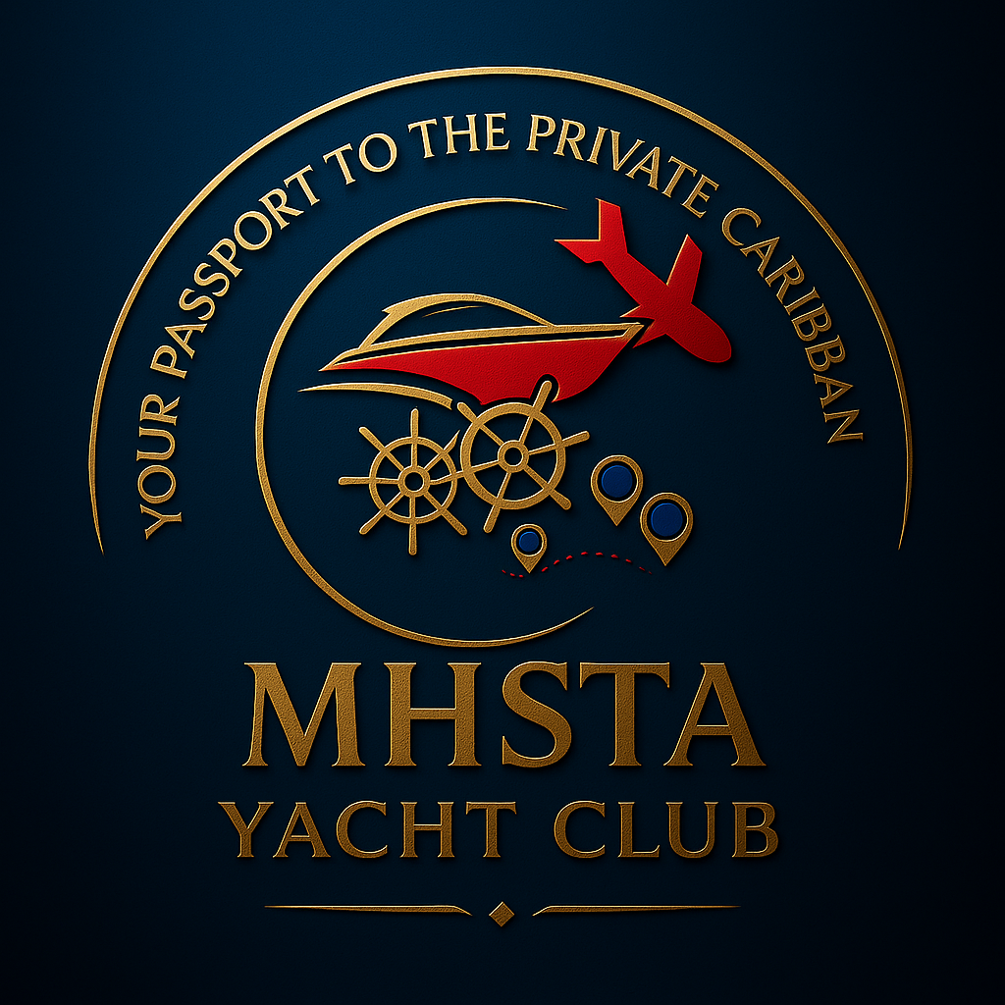

MHSTA Yacht Club – Business Plan
Executive Overview
The MHSTA Yacht Club is being built on a premise most business plans avoid: proof matters more than polish, and service to the general public is not a weakness—it is the strategy.
Anyone with sufficient capital could acquire and operate this marina. What separates this project is not access to money or novelty, but execution discipline and a fundamentally different view of who boating and yachting/boating are for. Misfits Legacy Ventures exists precisely because traditional lanes, ceilings, and silos constrain what businesses are willing to attempt.
This first location is intentionally designed as a proof-of-concept, not a showcase. Cincinnati is where systems are tested, services are refined, people are employed, and operational credibility is earned. Expansion is not assumed; it is conditioned on demonstrated performance.
The long-term ambition is global, but the operating posture is local, deliberate, and accountable.
The Asset & Opportunity
The initial asset is an established inland marina located on a major river corridor with consistent recreational traffic, seasonal Great Loop transits, and a diverse mix of personal craft and transient vessels. The opportunity lies less in altering the physical footprint and more in redefining how the asset is operated and who it serves.
Rather than optimizing for a narrow customer segment, the MHSTA Yacht Club is structured to serve a broad public—small-boat owners, transient cruisers, first-time participants, and community members who may never own a vessel. This inclusivity is not ideological; it is economic. Broad access increases utilization, resilience, and long-term relevance.
Historically, the asset has been under-marketed and lightly managed. The strategy going forward is operational consistency and service depth. The marina becomes a destination through reliability and care, allowing performance—not projections—to validate future growth.
Operating Model
The operating model is intentionally simple and sequenced. Complexity is introduced only when operational capacity and demand justify it.
Years 1–2 emphasize direct oversight, predictable service delivery, and disciplined decision-making. Fuel, dock operations, and light-to-intermediate repairs form the operational backbone. Membership programming is treated as infrastructure, not promotion.
Years 3–5 introduce delegation and selective growth, conditioned on usage data and staff readiness. Capital-intensive services are evaluated through demonstrated demand rather than forward projections.
This model is designed to function under conservative conditions and to scale cleanly when utilization accelerates.
Revenue Streams & Timing
Revenue is intentionally diversified across fuel sales, slips and dockage, repair and maintenance services, memberships, and ancillary programming. Each stream reinforces the others, creating resilience across seasonal and economic cycles.
Financial Summary
The five-year financial forecast reflects disciplined assumptions, staged investment, and accountability at each phase. Revenue growth is tied directly to operational milestones rather than speculative expansion. Capital expenditures are triggered by demand conditions rather than fixed timelines.
(the detailed financials are available upon request)
Closing Position
The MHSTA Yacht Club is not an attempt to outshine existing marina models. It is an effort to outserve them.
By rejecting rigid assumptions and prioritizing execution over appearance, this business creates a durable foundation for growth. It is designed to look modest when restraint is required, perform reliably at all times, and expand only when proof demands it.
For those who recognize that lasting value is built through service, discipline, and inclusion, this represents participation in a model intended to endure locally, replicate responsibly, and scale globally over time.

